19th December 2019

**Dubai Duty Free Celebrates 36 Years of Retailing Service**

***Announced 5 lucky Dubai Winners in Dubai Duty Free Millennium Millionaire and Finest Surprise Promotion***

**Summary:** Dubai Duty Free marked its 36th anniversary in style as it welcomed passengers travelling through Dubai International with a special 25% discount on a wide range of merchandise over three days which began at midnight on 18th December and will continue until the operation’s anniversary day, tomorrow, 20th December.

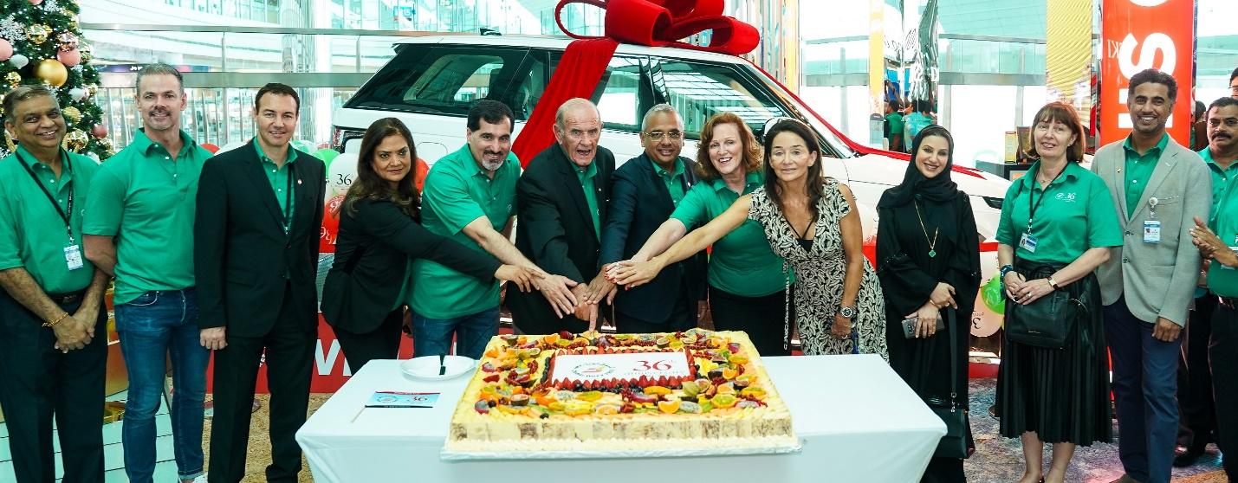

The Dubai Duty Free executive team led by Colm McLoughlin, Executive Vice Chairman & CEO and Ramesh Cidambi, COO at the ceremonial cutting of the 36th anniversary cake in Concourse B. Also in the picture are Salah Tahlak, EVP – Corporate Services, Sinead El Sibai, SVP – Marketing, Bernard Creed, SVP-Finance, Saba Tahir, SVP – Purchasing, Mona Al Ali, SVP – HR, Michael Schmidt, SVP – Retail Support, Sharon Beecham, VP – Purchasing, Zayed Al Shebli, VP - Loss Prevention and Corporate Security and Anita Mehra, SVP - Communication & Reputation of Dubai Airports.

Dubai Duty Free marked its 36th anniversary in style as it welcomed passengers travelling through Dubai International with a special 25% discount on a wide range of merchandise over three days which began at midnight on 18th December and will continue until the operation’s anniversary day, tomorrow, 20th December.

The anniversary discount over 72 hours saw a spending spree at Dubai International and at Al Maktoum International airports and is sure to signal a good end to the year.

Commenting on the success of 36th anniversary, Colm McLoughlin, Executive Vice Chairman & CEO of Dubai Duty Free said: “The anniversary celebrations spread over three days are fantastic. and we are glad to see such positive sales results across all the concourses. Extending a 25% discount to our customers is our way of saying thank you for their support throughout the year.”

The Dubai Duty Free anniversary promotion is now a highly-anticipated event with many travelers choosing to travel on the days when the 25% discount is offered. The first anniversary sale Dubai Duty Free introduced was on its 20th Anniversary in 2003.

The 36th anniversary also saw a series of celebrations in various locations over the past few days led by Mr. McLoughlin and members of the senior management team. The activities attracted a few well-known faces such as Noha Nabil, a Kuwaiti style icon and social media influencer who joined the Dubai Duty Free team to celebrate in Concourse A, while Wimbledon Champion and World No. 4 tennis player Simona Halep joined the Dubai Duty Free group in Concourse D.

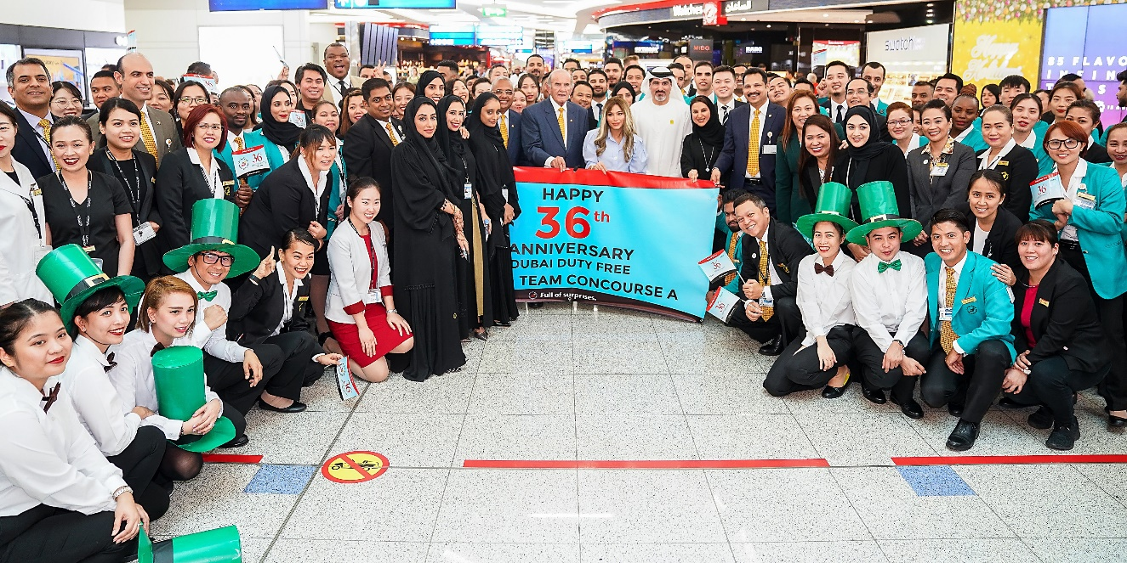

Noha Nabil, a Kuwaiti style icon and social media influencer joined the Dubai Duty Free team to celebrate the retailers 36th Anniversary in Concourse A.

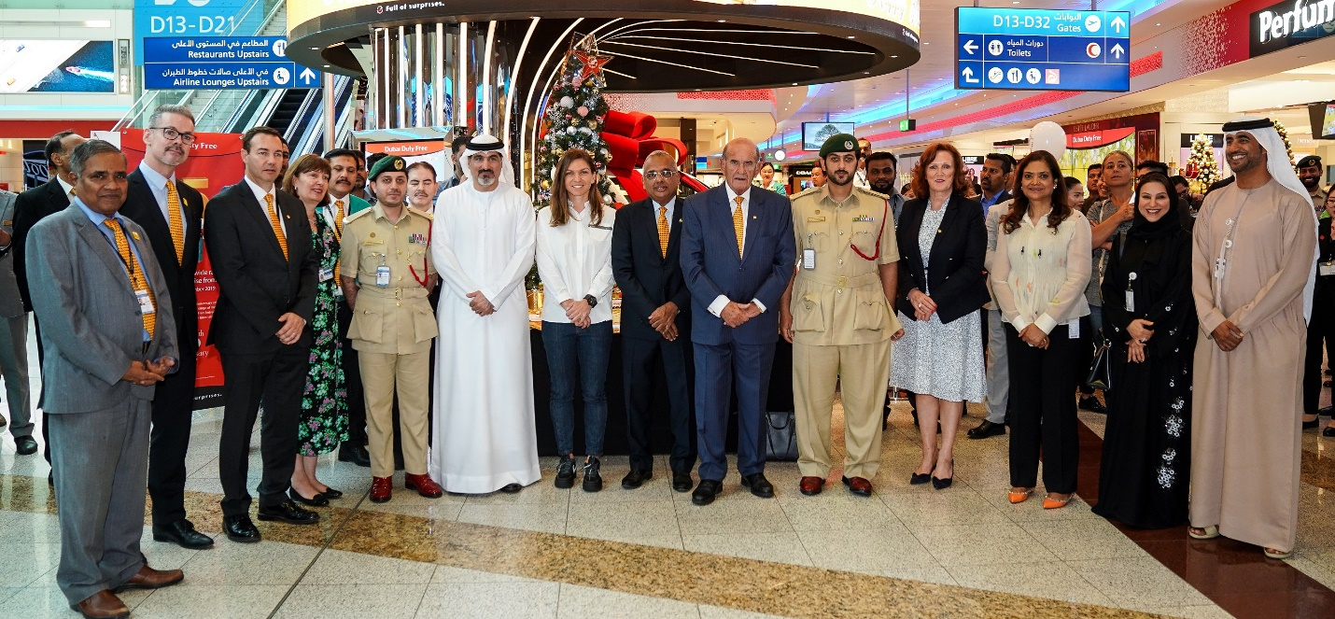

Wimbledon Champion and World No. 4 tennis player and Dubai Duty Free Tennis Championships WTA Ambassador Simona Halep joined the Dubai Duty Free group in Concourse D.

As part of today’s celebration, the group announced two winners of US$1 million in the Dubai Duty Free Millennium Millionaire in Series 318 and Series 319, and three winners in the Finest Surprise promotion.

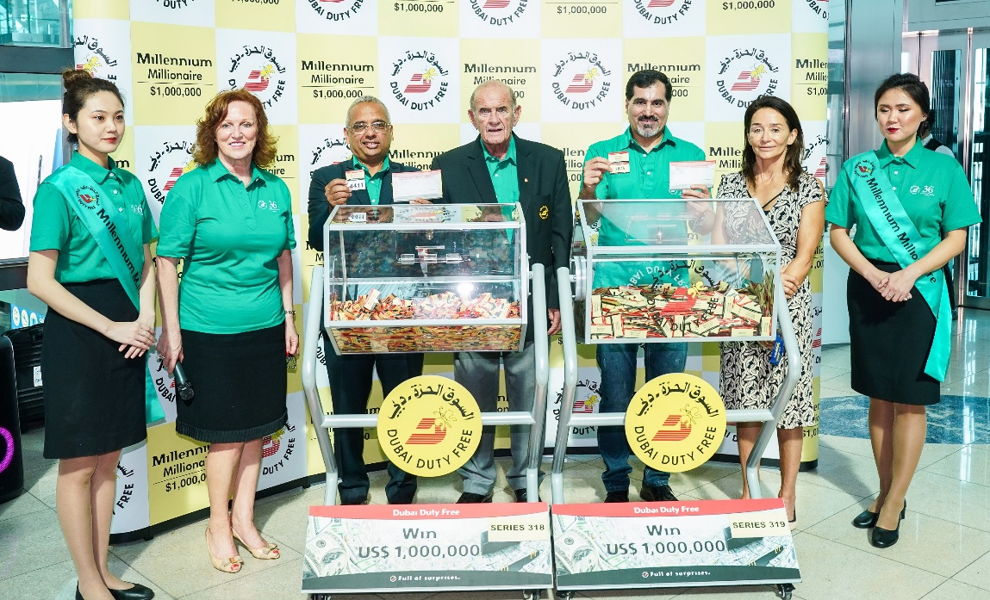

The Dubai Duty Free Millennium Millionaire draw for Series 318 and 319 was conducted by Colm McLoughlin, Executive Vice Chairman & CEO, Ramesh Cidambi, COO, Salah Tahlak, EVP – Corporate Services, Sinead El Sibai, SVP – Marketing and Anita Mehra, SVP - Communication & Reputation of Dubai Airports.

Mr. Vikrant Biswakarma, an Indian national will be pleasantly surprised when he learns that he just became a US$1 million winner in Series 318 with ticket number 4411, which he purchased online. Mr. Biswakarma is currently not available for immediate comment.

Meanwhile, Christmas and birthday (27th December) gifts came early to Mrs. Melody Curitana, a 33 year old Filipina based in Dubai when she won US$1 million in Series 319 with ticket number 1875. A Dubai resident for four years and soon-to-be a mother of two, Mrs. Curitana tried her luck for the first time when she purchased her ticket online. She was hoping to win the million dollars so that she can become a full time mother to her first child and the second baby.

Mrs. Curitana, who works for an insurance company, was very emotional on hearing about her win and commented, “Thank you so much Dubai Duty Free, this is an answered prayer. This is a big help for my family here in Dubai and in the Philippines. Thank you also for this early Christmas and birthday gift to me, I will never forget this day!”

Mrs. Curitana is the 12th Filipino national to win the promotion since its inception in 1999.

The draw was conducted by Colm McLoughlin, Executive Vice Chairman & CEO, Ramesh Cidambi, COO, Salah Tahlak, EVP – Corporate Services, Sinead El Sibai, SVP – Marketing and Anita Mehra, SVP - Communication & Reputation of Dubai Airports.

Following the Millennium Millionaire., three luxury vehicle winners were also unveiled at Dubai Duty Free Finest Surprise draw.

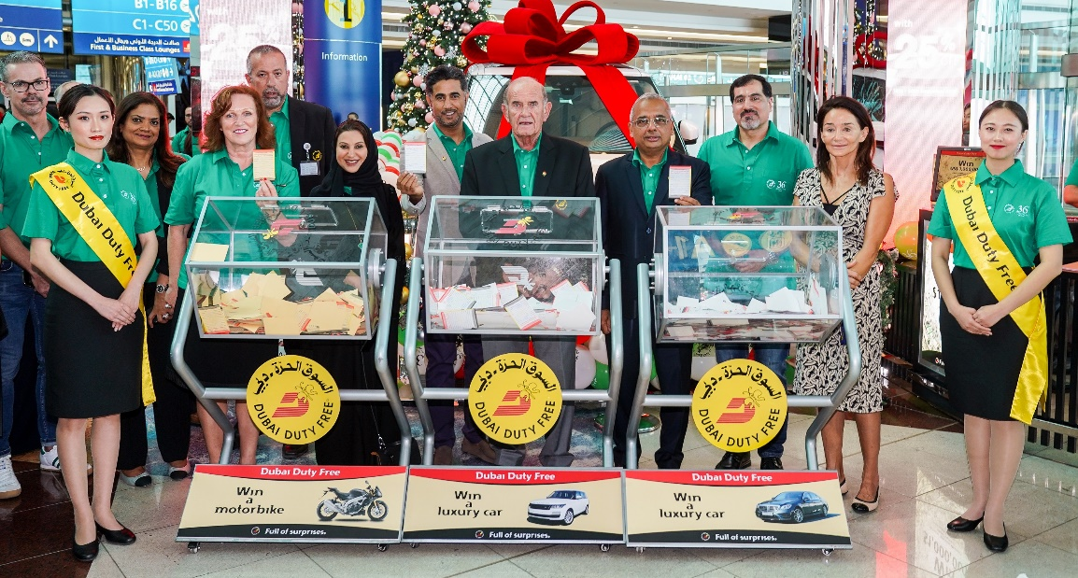

The Dubai Duty Free Finest Surprise draw for two cars and 1 motorbike was conducted by Colm McLoughlin, Executive Vice Chairman & CEO, Ramesh Cidambi, COO, Salah Tahlak, EVP – Corporate Services, Sinead El Sibai, SVP – Marketing, Bernard Creed, SVP-Finance, Saba Tahir, SVP – Purchasing, Mona Al Ali, SVP – HR, Zayed Al Shebli, VP - Loss Prevention and Corporate Security and Anita Mehra, SVP - Communication & Reputation of Dubai Airports.

Mr. William Duncan, a 60 year old British national based in Dubai became the owner of a Mercedes Benz S560 (Diamond White) when his ticket number 0509 in Series 1739 was drawn today.

A Dubai resident for over 30 years, Mr. Duncan, who works for Dubai Petroleum bought his ticket when he travelled to Bangkok in November.

A long-time participant to Dubai Duty Free for 10 years now, Mr. Duncan was delighted to learn of his win and said: “Thank you very much Dubai Duty Free, I’m very fortunate to have finally won.”

The second car winner is Mr. Raif Synowzik, a 50 year old Dubai-based German national, who will be driving away in a Range Rover HSE 360PS (Fuji White), for ticket number 0657 in Series 1740 which he also bought online. A resident of Dubai since 2010 and a regular participant to Dubai Duty Free promotions for 5 years now, Mr. Synowzik works as a facility manager for a logistic company in Dubai World Central and is thankful of his luck.

“Thank you so much Dubai Duty Free for this surprise and I hope to win US$1 million next time!”

Lastly, Mr. Mohammed Momin, a Dubai-based Indian national who won an Aprilla Tuono RR (Grigio) motorbike in Series 391 with ticket number 0504, is unavailable for immediate comment but will surely be surprised by his win.

Also present at the draw was Bernard Creed, SVP-Finance, Saba Tahir, SVP – Purchasing, Mona Al Ali, SVP – HR and Zayed Al Shebli, VP - Loss Prevention and Corporate Security.

The Dubai Duty Free staff also enjoyed a special ‘Staff Surprise’ draw.

Dubai Duty Free currently employs 6,100 staff and of the original 100 staff who joined in December 1983, 25 remain in active service and are referred to as the ‘Pioneers’.

* Ends -

For further information, please contact Bernard Aquino, Marketing Department,

Dubai Duty Free or call Tel: +9714-6019232 or email: [bernard.aquino@ddf.ae](mailto:bernard.aquino@ddf.ae)